Reset Module.
- Make a new project and select Module You want to Reset.
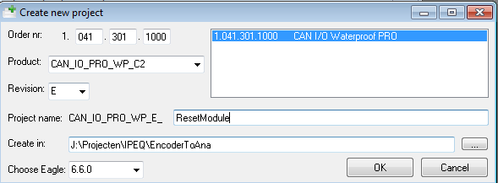
- Press Compile.
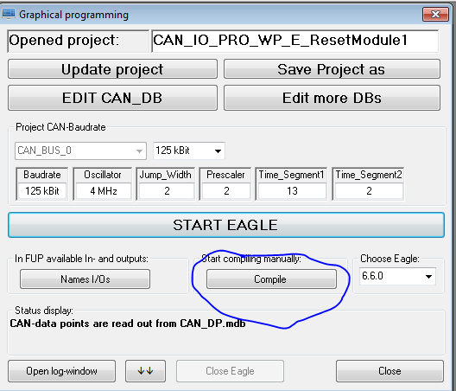
- Selecteer Flasher.Power Up module and press “Scan” witin 1 second after startUp.
Maybe you have to do it a couple of times.
- If Module is recognized, download S19 file with empty project.
- Now Your module is ready for downloading the file that you want.
